Ideation Phase
Brainstorm & Idea Prioritization Template
Date | 03 October 2026
Team ID | SWTID-2026-3758
Project Name | Streamlining IT Procurement: Automating Standard Laptop Orders with Flow Designer
Maximum Marks | 4 Marks
Brainstorm & Idea Prioritization Template:
In our brainstorming session, both team members shared ideas openly and did not judge each other’s suggestions. We aimed to collect as many ideas as possible and built on each other’s thoughts to find ways of simplifying how standard laptops are ordered and fulfilled in ServiceNow.
The session was carried out on a shared digital board so that every idea was recorded in one place. The steps below show how we selected our problem statement, listed and grouped our ideas, and ranked them by importance and feasibility.
Reference: https://www.mural.co/templates/brainstorm-and-idea-prioritization
Step-1: Team Gathering, Collaboration and Select the Problem Statement
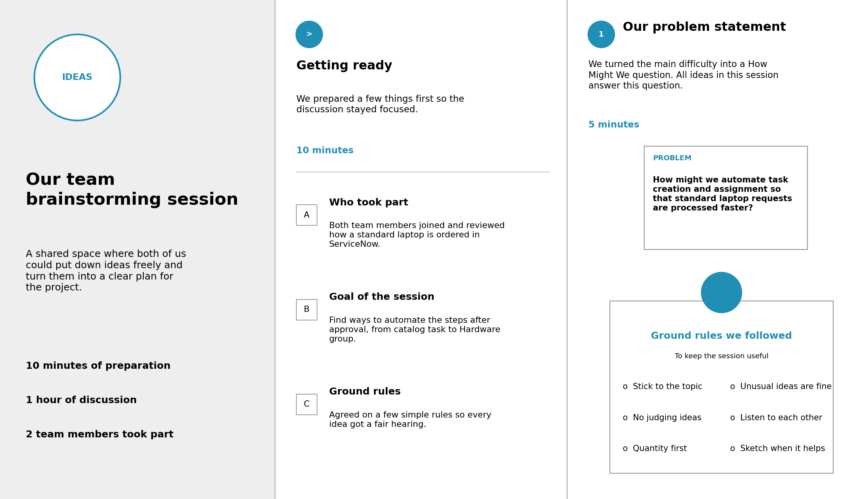
Identified Problems
- Manual laptop request processing.
- Delayed approval workflow.
- Manual catalog task creation.
- Incorrect task assignment.
- Lack of automation in procurement process.
- Increased processing time.
- Limited request tracking visibility.
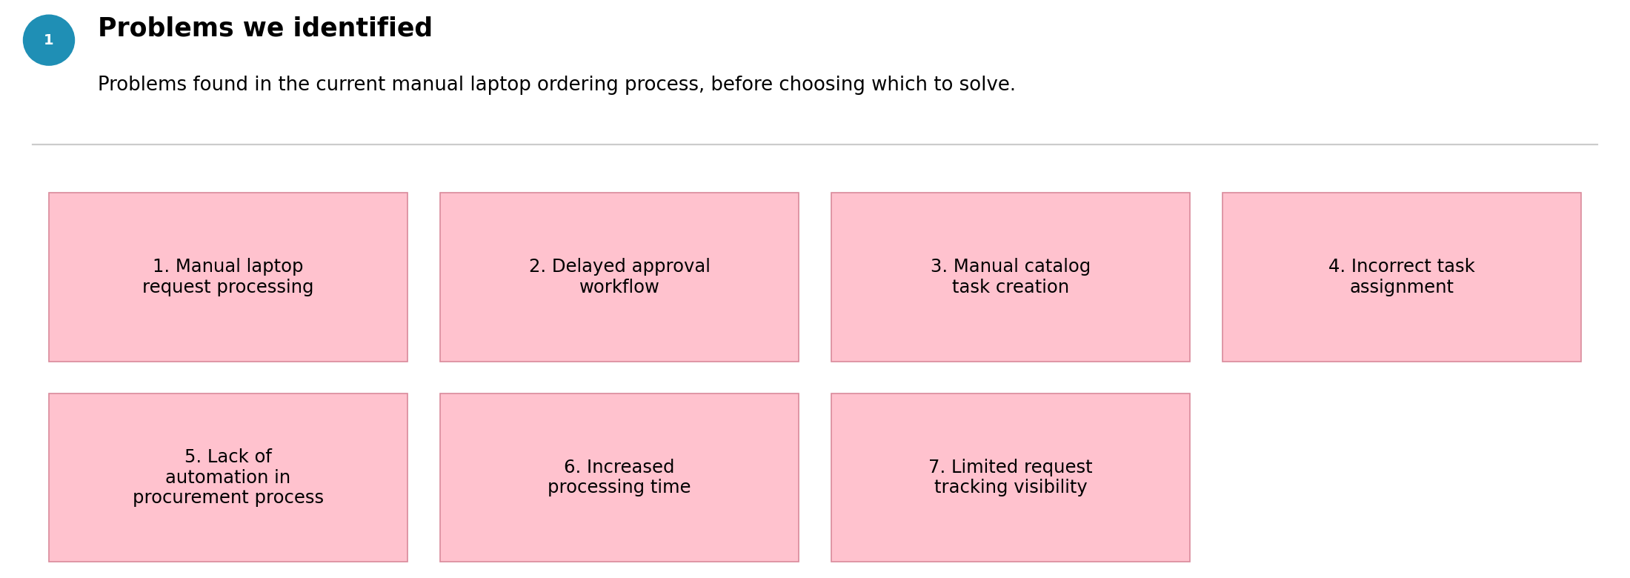
Step-2: Brainstorm, Idea Listing and Grouping
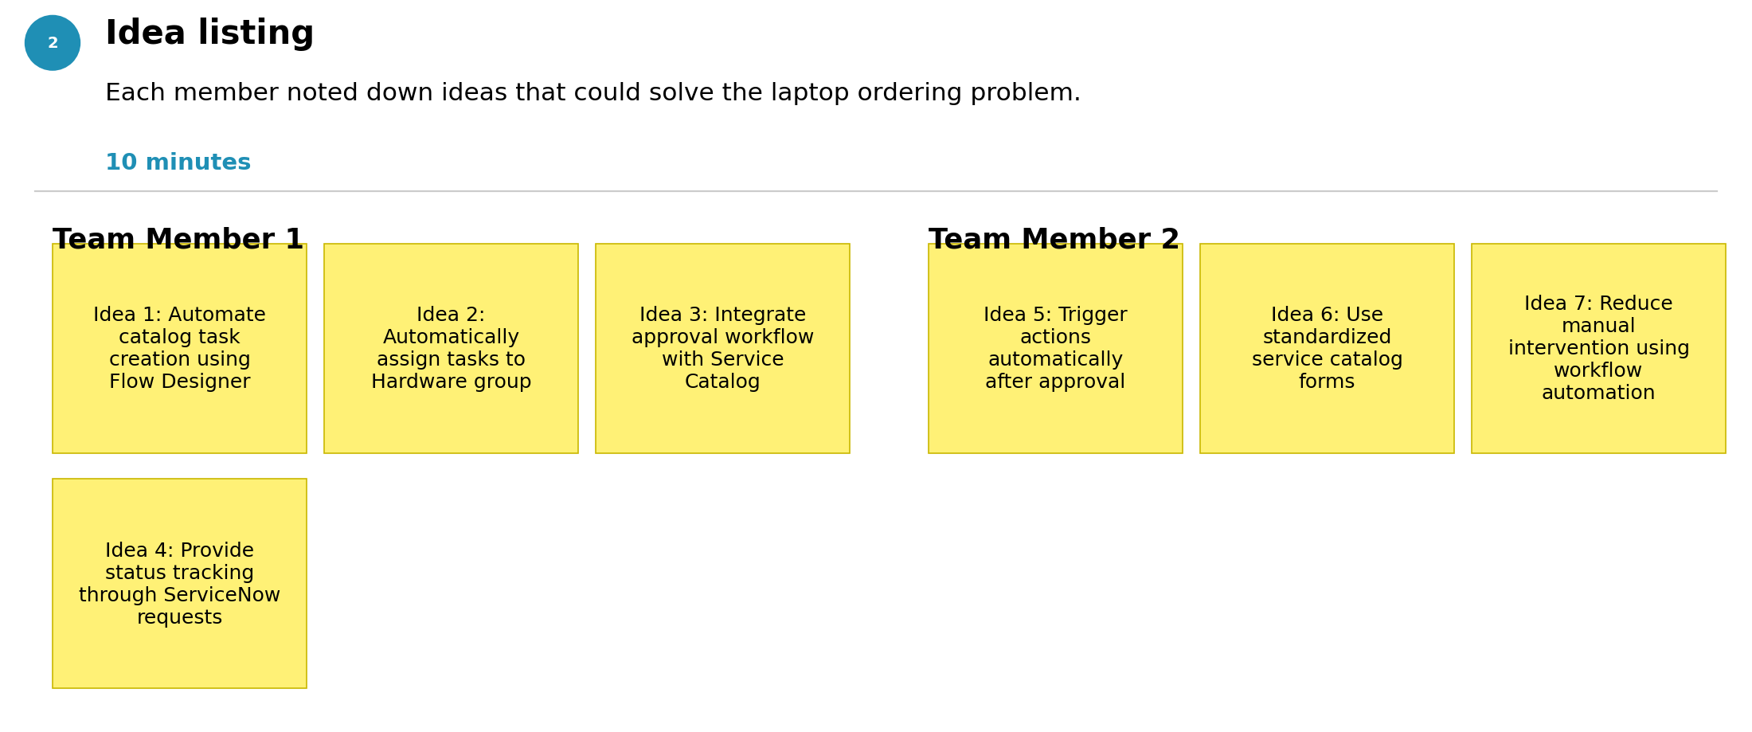
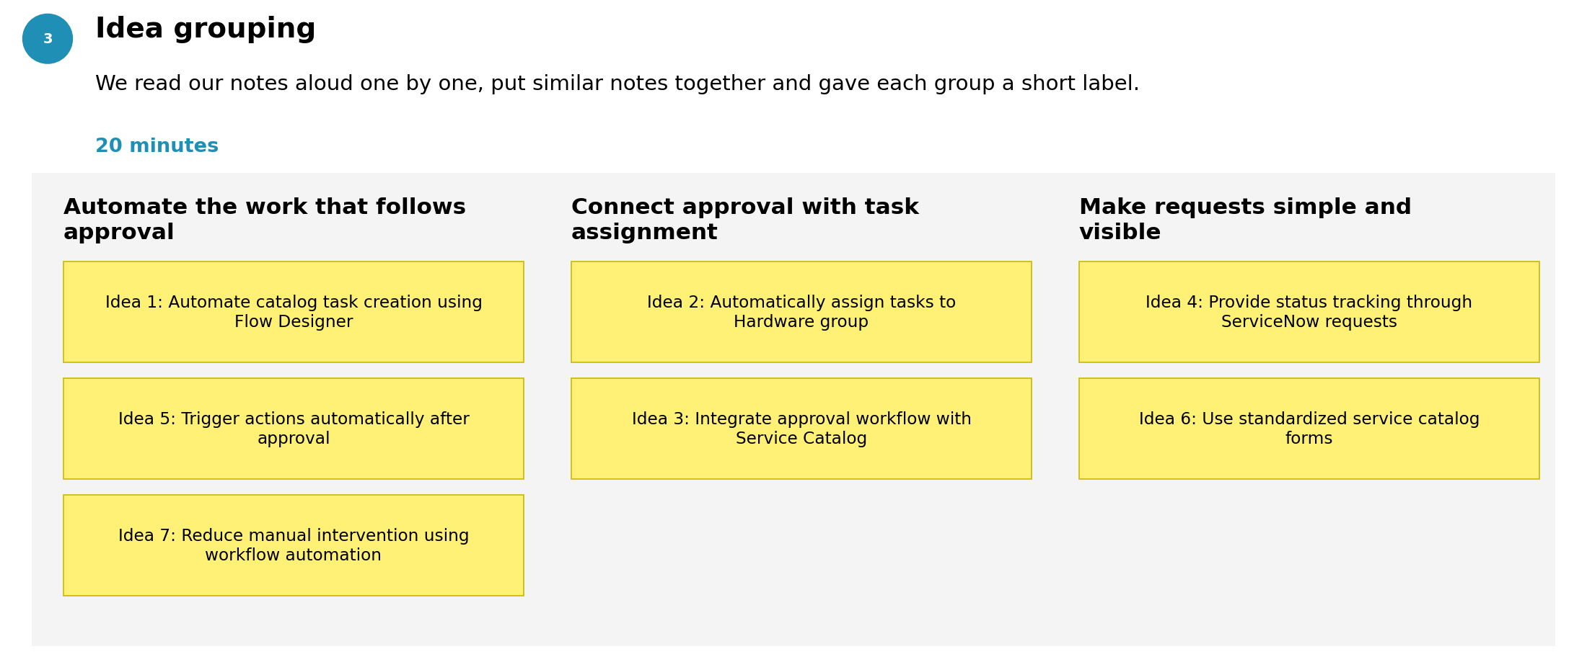
Ideas listed
- Automate catalog task creation using Flow Designer.
- Automatically assign tasks to Hardware group.
- Integrate approval workflow with Service Catalog.
- Provide status tracking through ServiceNow requests.
- Trigger actions automatically after approval.
- Use standardized service catalog forms.
- Reduce manual intervention using workflow automation.
Step-3: Idea Prioritization
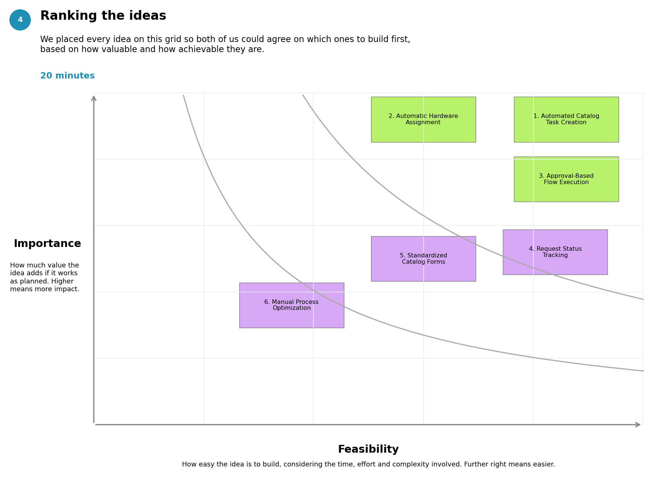
Idea | Importance | Feasibility | Priority
Automated Catalog Task Creation | High | High | 1
Automatic Hardware Assignment | High | High | 2
Approval-Based Flow Execution | High | High | 3
Request Status Tracking | Medium | High | 4
Standardized Catalog Forms | Medium | High | 5
Manual Process Optimization | Medium | Medium | 6
Selected Solution: Automate the Standard Laptop Order process using ServiceNow Flow Designer, Service Catalog, Approval Workflow, and Automatic Catalog Task Assignment to the Hardware Team.

Ideation Phase
Define the Problem Statements
Date | 03 October 2026
Team ID | SWTID-2026-3758
Project Name | Streamlining IT Procurement: Automating Standard Laptop Orders with Flow Designer
Maximum Marks | 2 Marks
Customer Problem Statement Template:
A problem statement describes a situation from the user’s side. For our project, we wrote statements from the viewpoint of the two groups affected by manual laptop ordering: the employee who places the order and the IT hardware team who fulfils it.
Writing the problem in this form helped us understand the real difficulty behind the process and decide what needs to be automated before moving on to the solution in Flow Designer.
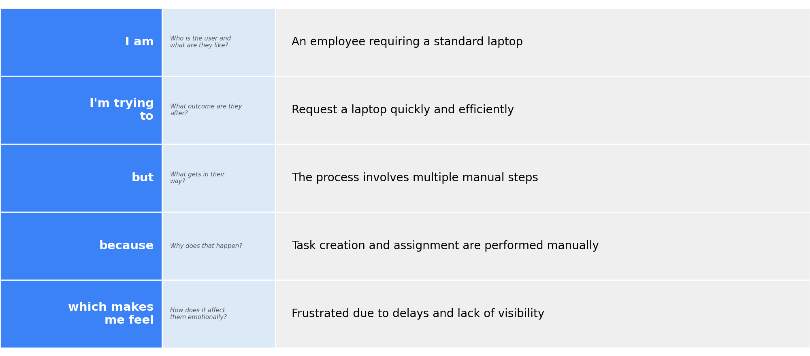
Reference: https://miro.com/templates/customer-problem-statement/
Example:
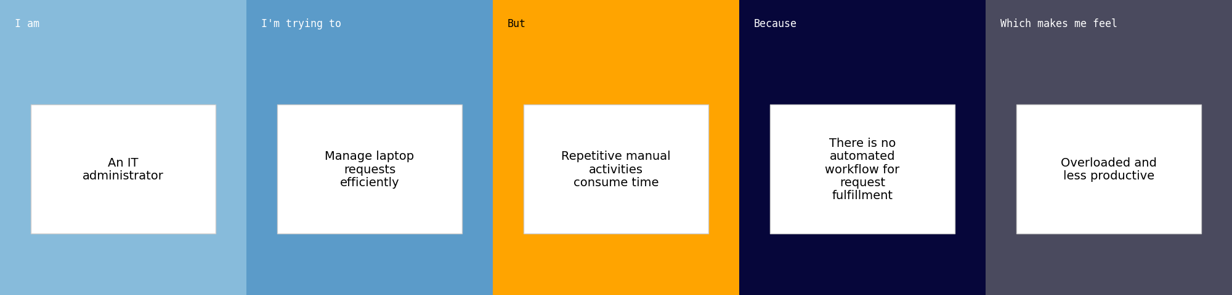
Problem Statement (PS) | I am (Customer) | I’m trying to | But | Because | Which makes me feel
PS-1 | An employee requiring a standard laptop | Request a laptop quickly and efficiently | The process involves multiple manual steps | Task creation and assignment are performed manually | Frustrated due to delays and lack of visibility
PS-2 | An IT administrator | Manage laptop requests efficiently | Repetitive manual activities consume time | There is no automated workflow for request fulfillment | Overloaded and less productive
Final Problem Statement
Employees and IT administrators face delays in the standard laptop procurement process due to manual approvals, manual task creation, and delayed assignment of requests. An automated workflow is required to improve efficiency, reduce manual effort, and provide faster service delivery.

Ideation Phase
Empathize & Discover
Date | 03 October 2026
Team ID | SWTID-2026-3758
Project Name | Streamlining IT Procurement: Automating Standard Laptop Orders with Flow Designer
Maximum Marks | 4 Marks

Empathy Map Canvas:
An empathy map shows what a user thinks, feels, hears, sees, says and does, along with their pains and gains. We used it to look at laptop ordering through the eyes of an employee who is waiting for a new laptop.
Mapping these points showed us where employees get stuck after their request is approved. This led directly to our idea of creating the catalog task and assigning it to the Hardware group automatically.
Reference: https://www.mural.co/templates/empathy-map-canvas
Example: Standard Laptop Ordering in ServiceNow
User persona: Employee requesting a standard laptop through the IT department
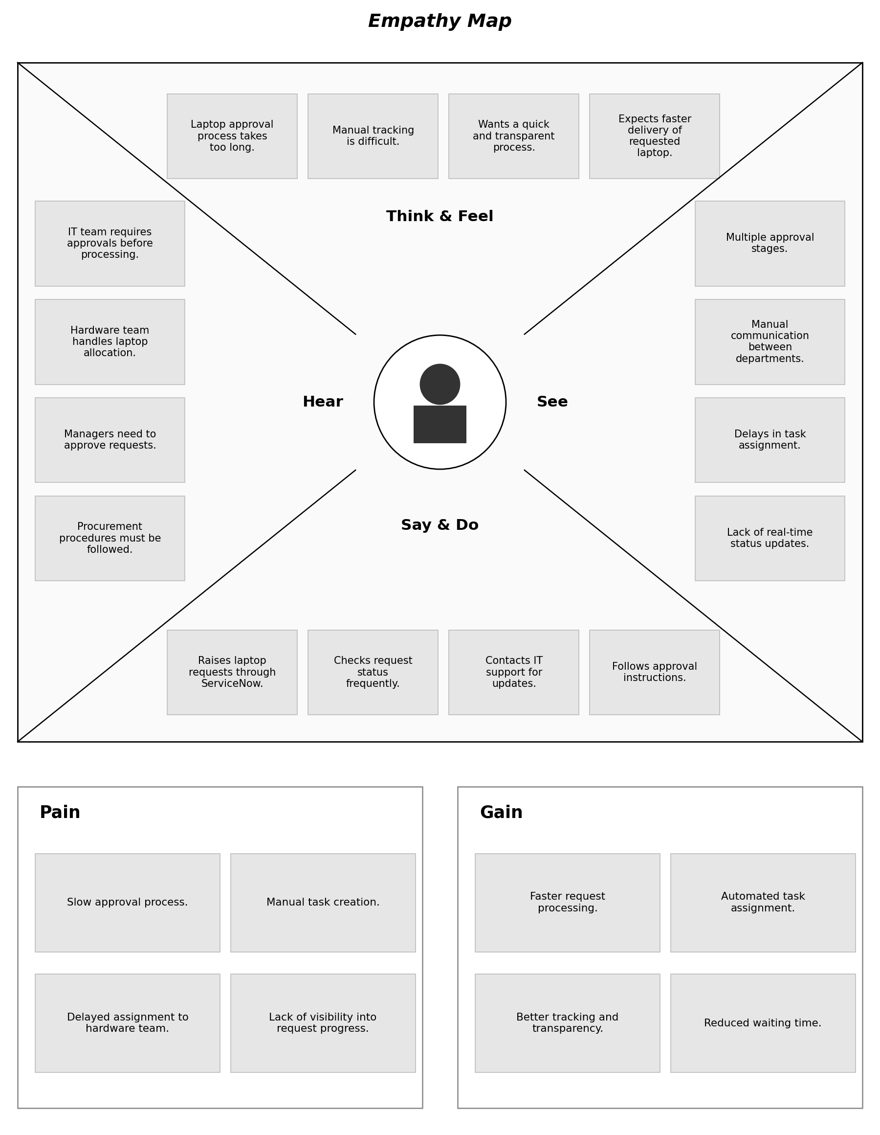
What does the user THINK & FEEL?  - Laptop approval process takes too long.  - Manual tracking is difficult.  - Wants a quick and transparent process.  - Expects faster delivery of requested laptop. | What does the user SEE?  - Multiple approval stages.  - Manual communication between departments.  - Delays in task assignment.  - Lack of real-time status updates.
What does the user HEAR?  - IT team requires approvals before processing.  - Hardware team handles laptop allocation.  - Managers need to approve requests.  - Procurement procedures must be followed. | What does the user SAY & DO?  - Raises laptop requests through ServiceNow.  - Checks request status frequently.  - Contacts IT support for updates.  - Follows approval instructions.
PAIN  - Slow approval process.  - Manual task creation.  - Delayed assignment to hardware team.  - Lack of visibility into request progress. | GAIN  - Faster request processing.  - Automated task assignment.  - Better tracking and transparency.  - Reduced waiting time.

